Civil war in Somalia

UNSC Resolution: | 814
Date of adoption: | 26-Mar-1993
Operative paragraph: | 13
Demand number: | 814,1311

Sarah-Myriam Martin-Brûlé

Wording of demand

immediately cease and desist from all breaches of international humanitarian law and reaffirms that those responsible for such acts be held individually accountable

List of addressees of the demand
- Government of Somalia, United Somali Congress Faction

Short-term compliance

Description of the addressee(s)’ conduct

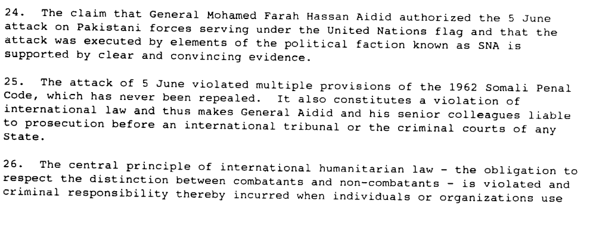

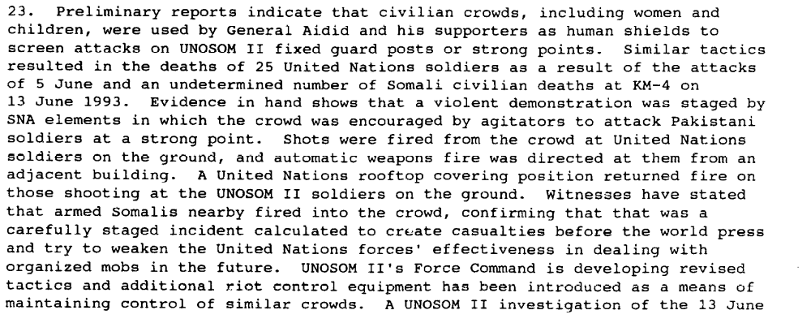
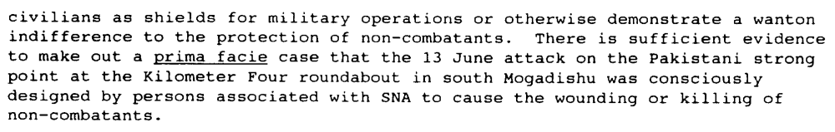

Report Pursuant to Paragraph 5 of Security Council Resolution 837 (1993) on the Investigation into the 5 June 1993 attack on United Nations Forces in Somalia conducted on behalf of the Secretary-General
S/26351 24 August 1993

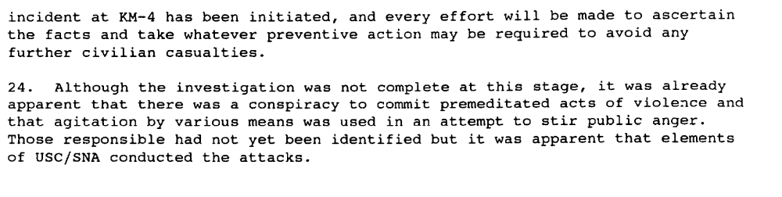

Report of the Secretary-General on the Situation in Somalia, S/26022

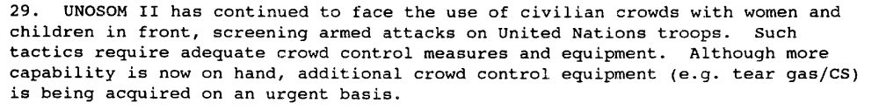

Report of the Secretary-General S/26022

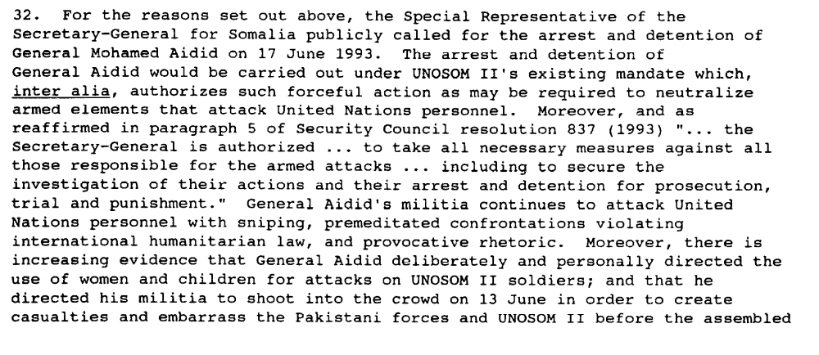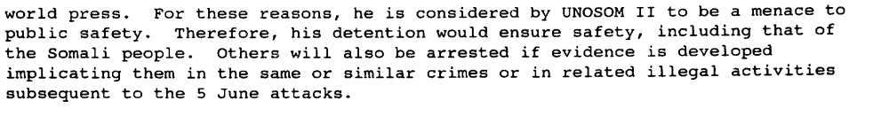

Report of the Secretary-General on the situation in Somalia, S/26022, 1 July 1993

Assessment

Short-term compliance
X No or marginal compliance (1) | Medium low compliance (2) | Medium high compliance (3) | Full or almost full compliance (4)

Considerations underlying the assessment

Within the six months following the adoption of the resolution, the demand addressees did not immediately cease nor did they desisted from all breaches of international humanitarian law.

Medium-term compliance

Description of the addressee(s)’ conduct

All Somali factions reportedly held prisoners arbitrarily in 1993. The International Committee of the Red Cross (ICRC) negotiated the release of 348 persons, mostly detained by the United Somali Faction (USC), but some by the Somali Salvation Democratic Front (SSDF), and the Somali National Force (SNF).
(...)
Violations of humanitarian law in internal conflicts by Somalis have been common since the civil war began in 1991. The use by factions of women and children as human shields or combatants in conflicts is well-documented. The brutalities of armed looters who continue to roam Somalia are unlikely ever to be completely catalogued. Humanitarian convoys and base camps were the targets of these bandits. The Geddo region on the border with Kenya, unprotected by UNOSOM deployment, suffered severely. When the remnants of Somalia's judiciary formed an association, they particularly wanted inquiries into war crimes to focus on the looting of relief supplies. Except in regions with UNOSOM protection, humanitarian aid workers were constantly under threat, often in pay disputes with their armed Somali employees. Three non-Somali humanitarian aid workers were murdered in incidents of random violence.

U.S. DEPARTMENT OF STATE. “SOMALIA HUMAN RIGHTS PRACTICES, 1993
JANUARY 31, 1994 U.S. DEPARTMENT OF STATE.
http://dosfan.lib.uic.edu/ERC/democracy/1993_hrp_report/93hrp_report_africa/Somalia.html

The warring factions continued to commit numerous violations of humanitarian law throughout the year, including the killing of many civilians, particularly in Mogadishu and Kismayo. In February heavy interfactional fighting between the forces of Colonel Omar Jess and General Mohammed Hersi Morgan in Kismayo killed at least 60 civilians. In April fighting between General Aideed's SNA militia and the Hawadle, a rival Hawiye subclan, in Merca and southern Mogadishu, killed another 32 civilians. At year's end, with the approaching departure of UNOSOM, heavy factional fighting in Mogadishu over access to the port area reportedly killed 20 persons and wounded hundreds more.

There was minimal progress toward reestablishing a system of justice in Somalia. The three-tier national judicial system based on the 1962 Criminal Code and the 1963 Penal Code that was prepared by UNOSOM in 1993 could not be implemented because
of the poor security situation. Although local authorities have attempted to administer some type of justice, few Somalis feel confident of protection from retaliation based on clan loyalties. By the end of the year, no civil courts functioned.

The vacuum created by the lack of a functioning government led to the expansion of the role of traditional clan-based Islamic courts. While in the past Islamic courts were used to settle property disputes, these courts increasingly heard criminal
cases. Anecdotal evidence suggests that the Islamic courts are applying a very strict interpretation of Shari'a law, as evidenced by the amputation sentence against two teenagers (see Section 1.c.). These informal courts are not standardized and
do not provide for procedural safeguards that meet accepted international standards for a fair trial. There is no right to appeal the verdict of the Islamic courts, and defendants
reportedly are not provided with legal counsel.

U.S. DEPARTMENT OF STATE. “SOMALIA HUMAN RIGHTS PRACTICES, 1994
JANUARY 31, 1995 U.S. DEPARTMENT OF STATE.
http://dosfan.lib.uic.edu/ERC/democracy/1993_hrp_report/93hrp_report_africa/Somalia.html

http://dosfan.lib.uic.edu/ERC/democracy/1994_hrp_report/94hrp_report_africa/Somalia.html

SOMALIA

Assessment

Medium-term compliance
X No or marginal compliance (1) | Medium low compliance (2) | Medium high compliance (3) | Full or almost full compliance (4)

Considerations underlying the assessment

Within the two years following the adoption of the resolution, the demand addressees did not ceased nor did they desisted from all breaches of international humanitarian law.

Depth of demand

Assessment

Level of depth of demand
Low depth of demand (1) | X Medium depth of demand (2) | High depth of demand (3)

Considerations underlying the assessment

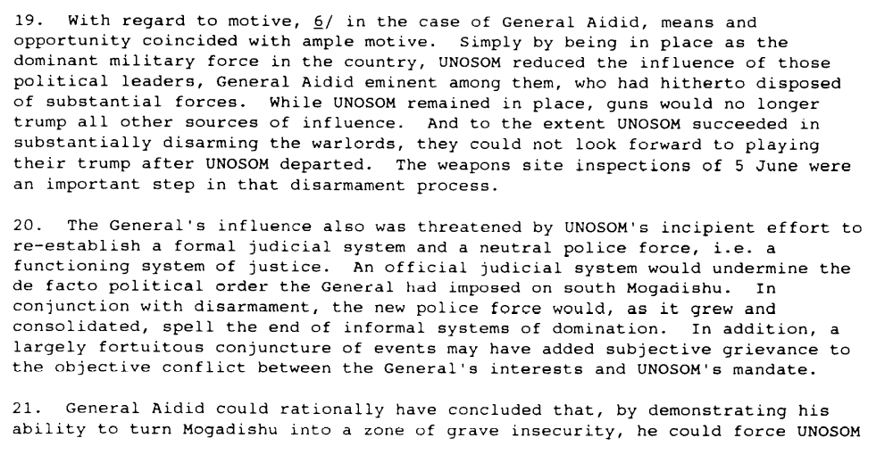

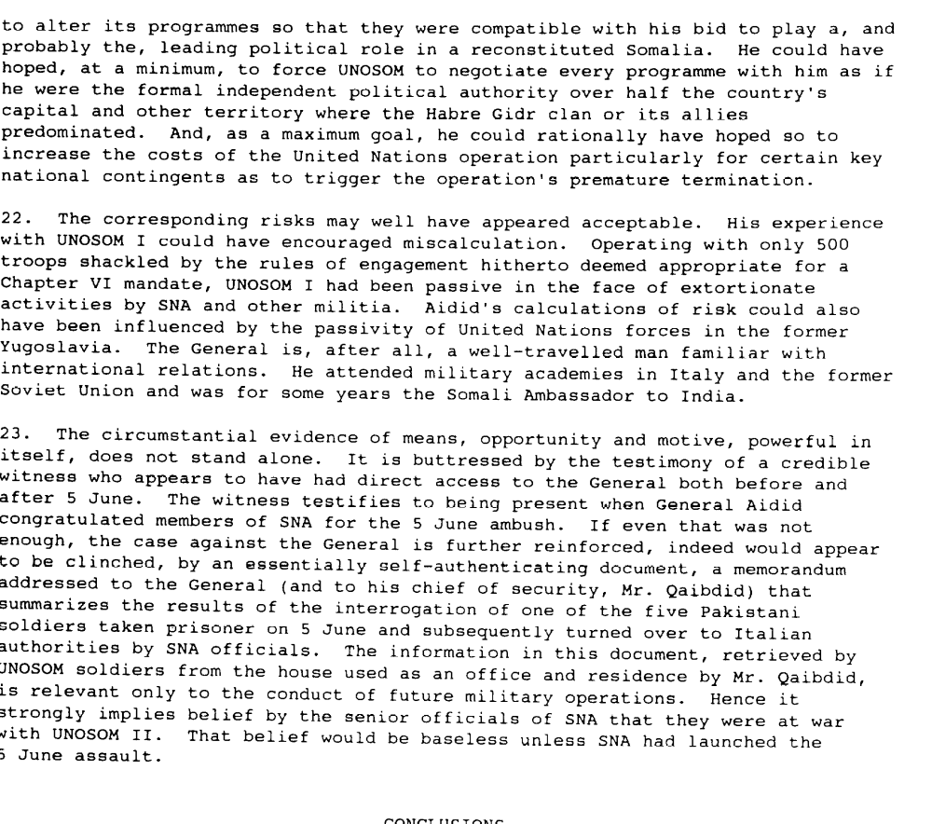

Report Pursuant to Paragraph 5 of Security Council Resolution 837 (1993) on the Investigation into the 5 June 1993 attack on United Nations Forces in Somalia conducted on behalf of the Secretary-General
S/26351 24 August 1993

Level of confidence about coding decisions

Level of confidence about coding decision
Extremely high | X High | Moderate

Comments to IPI (if any)

